**Pin Configuration of 8085**

[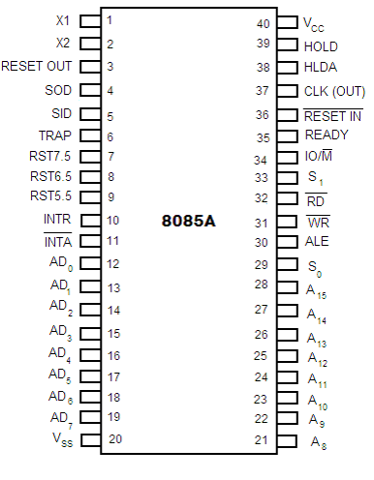](http://www.google.com.np/url?sa=i&rct=j&q=&esrc=s&source=images&cd=&cad=rja&uact=8&ved=0ahUKEwjKyqujlJLVAhUE2LwKHaACCDgQjRwIBw&url=http://scanftree.com/microprocessor/Pin-Diagram-of-8085-and-Pin-description-of-8085&psig=AFQjCNG7m6F9Fpx7LBhL1zEU_9w09BWMAQ&ust=1500444170400499)

**Architecture of 8085 Microprocessor**



**Programming Model OR Register Organisation of 8085**

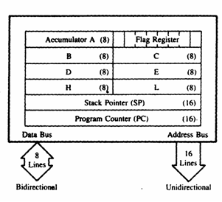

**Flag Register OR Status Flags OR PSW of 8085**

